# 

# **Pizza Hut Sales Analysis Using SQL**

**Database Software Used: MySQL**

**Database: pizzahut**

**Tables:**

**Pizzas : Orders:**

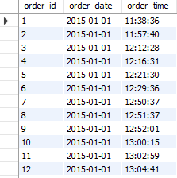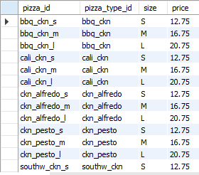

**Pizza Types:**

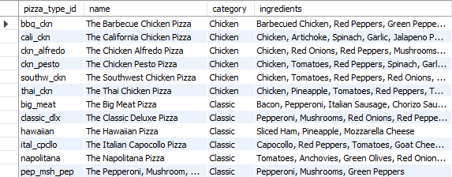

**Order_Details:**

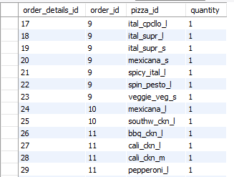

**Queries:**

**Basic:**

1. **Retrieve the total number of orders placed.**



**Output:**

**The total number of orders placed are 21350.**



1. **Calculate the total revenue generated from pizza sales.**

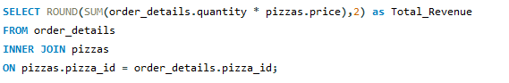

**Output:**

**The total revenue generated is as follows:**



1. **Identify the highest-priced pizza.**

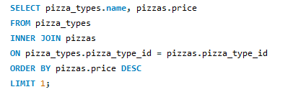

**Output:**

**The highest priced pizza is:**



1. **Identify the most common pizza size ordered.**

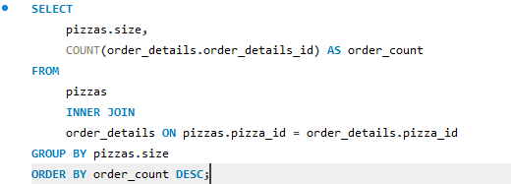

**Output:**

**It is as follows:**

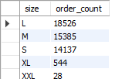

1. **List the top 5 most ordered pizza types along with their quantities.**

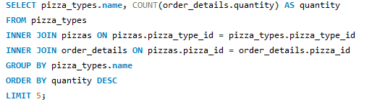

**Output:**

**The top 5 most ordered pizzas with their quantities are:**

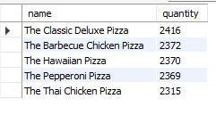

**Intermediate:**

1. **Join the necessary tables to find the total quantity of each pizza category ordered.**

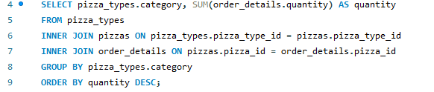

**Output:**

**The total quantity for each category is as follows:**

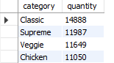

1. **Determine the distribution of orders by hour of the day.**



**Output:**

**The distribution of orders by hour of the day is as follows:**

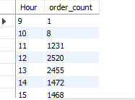

1. **Join relevant tables to find the category-wise distribution of pizzas.**

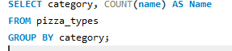

**Output:**

**The category-wise distribution of pizzas is as follows:**

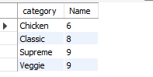

1. **Group the orders by date and calculate the average number of pizzas ordered per day.**

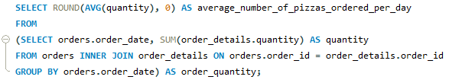

**Output:**

**The average number of pizzas ordered per day is:**



1. **Determine the top 3 most ordered pizza types based on revenue.**

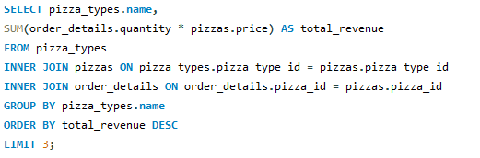

**Output:**

**The top 3 most ordered pizza types based on revenue are:**

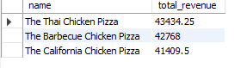

**Advanced:**

1. **Calculate the percentage contribution of each pizza type to total revenue.**

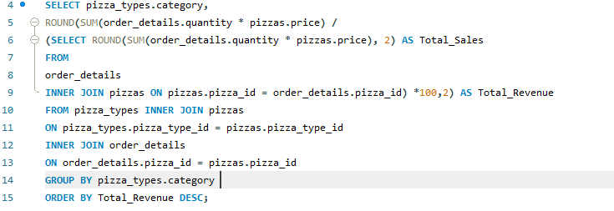

**Output:**

**The percentage contribution of each pizza type to total revenue is:**

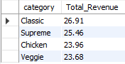

1. **Analyse the cumulative revenue generated over time.**

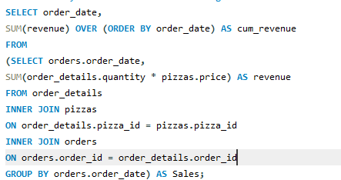

**Output:**

**The cumulative revenue generated over time is:**

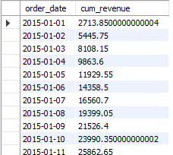

1. **Determine the top 3 most ordered pizza types based on revenue for each pizza category.**

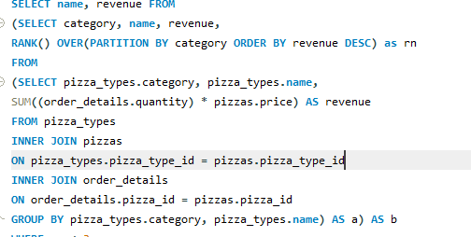

**Output:**

**The top 3 most ordered pizza types based on revenue and category:**

